12th Industrialists Conference
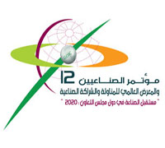
Organizer: Gulf Organization for Industrial Consulting (GOIC)
Period: 3
From: 22-11-2009 To: 24-11-2009
Location: Qatar International Exhibition Centre
City: Doha – State of Qatar

Under Auspices: Sheik Hamad bin Khalifa Al-Thani, Emir of the State of Qatar
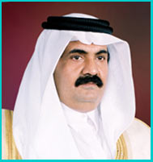
The Industrialists Conference 2009 is the most prestigious of its kind in the GCC (Gulf Cooperation Countries) region. It is held every two years in a different country, and is attended by the six Ministers of Industry of the GCC countries. The key topics to be covered in the conference, in its 12th edition, include future industry in GCC countries vision 2020, strategic initiatives in industrial policy formulation and co-ordination, projects financing and financial services, international co-operation in research and technology, industrial linkages and partnerships, new trends in supply chain management, and industrial products and potential market. The conference will be accompanied by the Global Exhibition on Industrial Subcontracting and Partnership- Petrochemicals and Plastics.
Contacts:
Phone: 009744858888
Fax: 009744934369

