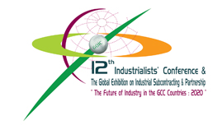
12th Industrialists' Conference & The Global Exhibition on Industrial Subcontracting & Partnership
Gulf Organization for Industrial Consulting is organizing the biggest event in the history of Gulf Industry With the cooperation Of Ministry of Energy and INDUSTRY ,Ministry of Business & Trade, Qatar Chamber of Commerce & Industry, The Cooperation Council for the Arab States of the Gulf-Secretariat General and Federation of GCC Countries and with the Support of Gulf Petrochemical & chemical association, under the patronage of H.E Shiekh Hamad Bin Khalifa Al-Thani , The Emir of the State of Qatar and the attendance of H.E Mr.Hamad Bin Adullah Al Attiyah – Prime Minister, Minister of Energy and Industry, and the attendance of the Six Ministers of Industry in the GCC Countries on 22-24 November 2009 in Qatar International Exhibition Center.

For more information please visit the event's Website
www.goic.org.qa/IndustrialistsConference

HH the Heir Apparent Sheikh Tamim Bin Hamad Al-Thani Opens Four-Day ‘Made In Qatar’ Expo

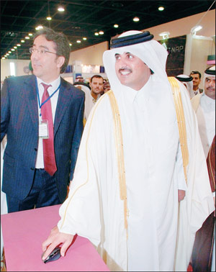
HH the Heir Apparent Sheikh Tamim bin Hamad al-Thani opened, on 11 January 2009, the ‘Made in Qatar’ exhibition, organized by Qatar Chamber of Commerce and Industry, at the Doha Exhibition Centre.
Among those present on the occasion HE the Deputy Prime Minister Minster of Energy & Industry Abdullah bin Hamada al-Attiyah, HE Yousef Hussein Kamal Minister of Economy and Finance, HE Dr. Mohamed Saleh Al-Sada State Minister for Energy and Industrial Affairs, HE Sheikh Khalifa Bin Jassem Bin Mohamed Al-Thani Chairman of Qatar Chamber of Commerce, their Excellencies sheikhs, Qatari businesspersons, and GCC chambers of commerce and industry chairpersons.
The four-day exhibition has attracted more the 270 firms working in Qatar. Soon after the inauguration, HH the Heir Apparent went on a tour of inspection at the venue, during which he launched the website to the Ministry of Energy & Industry.

Panel to help streamline small units soon

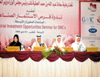
A committee is to be set up to streamline licensing procedures and help small and medium size industries’ units in the Industrial Area, Deputy Premier and Minister of Industry and Energy H E Abdullah bin Hamad Al Attiyah said yesterday.
The committee to be chaired by Minister of State for Energy and Industrial Affairs, Dr. Mohammed Saleh Al Sada, has been tasked with finding solutions on licensing procedures and market policies so that SMIs can obtain maximum benefits from the Industrial Area.
He said unfortunately there have been several cases where investors have attempted to sell the plots devoted to SMIs which is illegal. “We are very strict about it,” he said, adding that strict measures will be taken against those who try to misuse the plot of land provided and will have their licenses withdrawn.
Al Attiyah was speaking at a seminar on industrial investment opportunities in Qatar which opened here yesterday. The seminar was organized by the Gulf Organization for Industrial Consulting (GOIC) in cooperation with the Qatar Chamber of Commerce and Industry (QCCI) and sponsored by Qatar Holding (QH).
He said there are regulations that should be respected and that it is illegal to transfer ownership of the land and license before the implementation of a project in the Industrial Area. The phase II of the Industrial Area covering approximately five million square metres area will come on stream by the end of 2009. The first phase of the Industrial Area attracted some $ 3bn investments from SMIs.

PETROLEUM EXECUTIVE OF THE YEAR

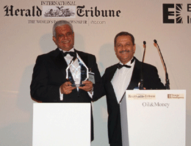
PETROLEUM EXECUTIVE OF THE YEAR: Deputy Premier and Minister of Energy and Industry HE Abdullah bin Hamad al-Attiyah after being presented with the Petroleum Executive of the Year 2007 award at a gala dinner at the Dorchester Hotel in London on Tuesday night 30 Oct 2007.
With him is Dr Shokri Ghanem, chairman of Libya National Oil Corporation, the previous winner of the Petroleum Executive of the Year award. The award presentation was the centrepiece of the 28th annual Oil & Money Conference, convened by the International Herald Tribune and Energy Intelligence

